
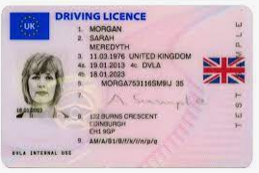


English Vocabulary – Renew / Renovate / Restore

to renew
(renewal)



to renovate
(renovation)

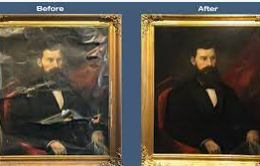

to restore
(restoration)

Synonyms of “renew”:
- to restart
- to extend
- to prolong

Synonyms of “renovate”:
- to modernize
- to redecorate
- to revamp
- to make over (phrasal verb) *
- to recondition
- to overhaul
- to repair
- to rebuild *
- to reconstruct
- to remodel

Synonyms of “restore”:
- to reinstate
- to refurbish
- to bring back (phrasal verb) *
- to re-establish

Other similar vocabulary
- to update
- to bring up to date *
- to re-equip
- to improve
- to better
- to retrofit
- to upgrade
- to reform (usually associated with politics)

* Irregular verbs

